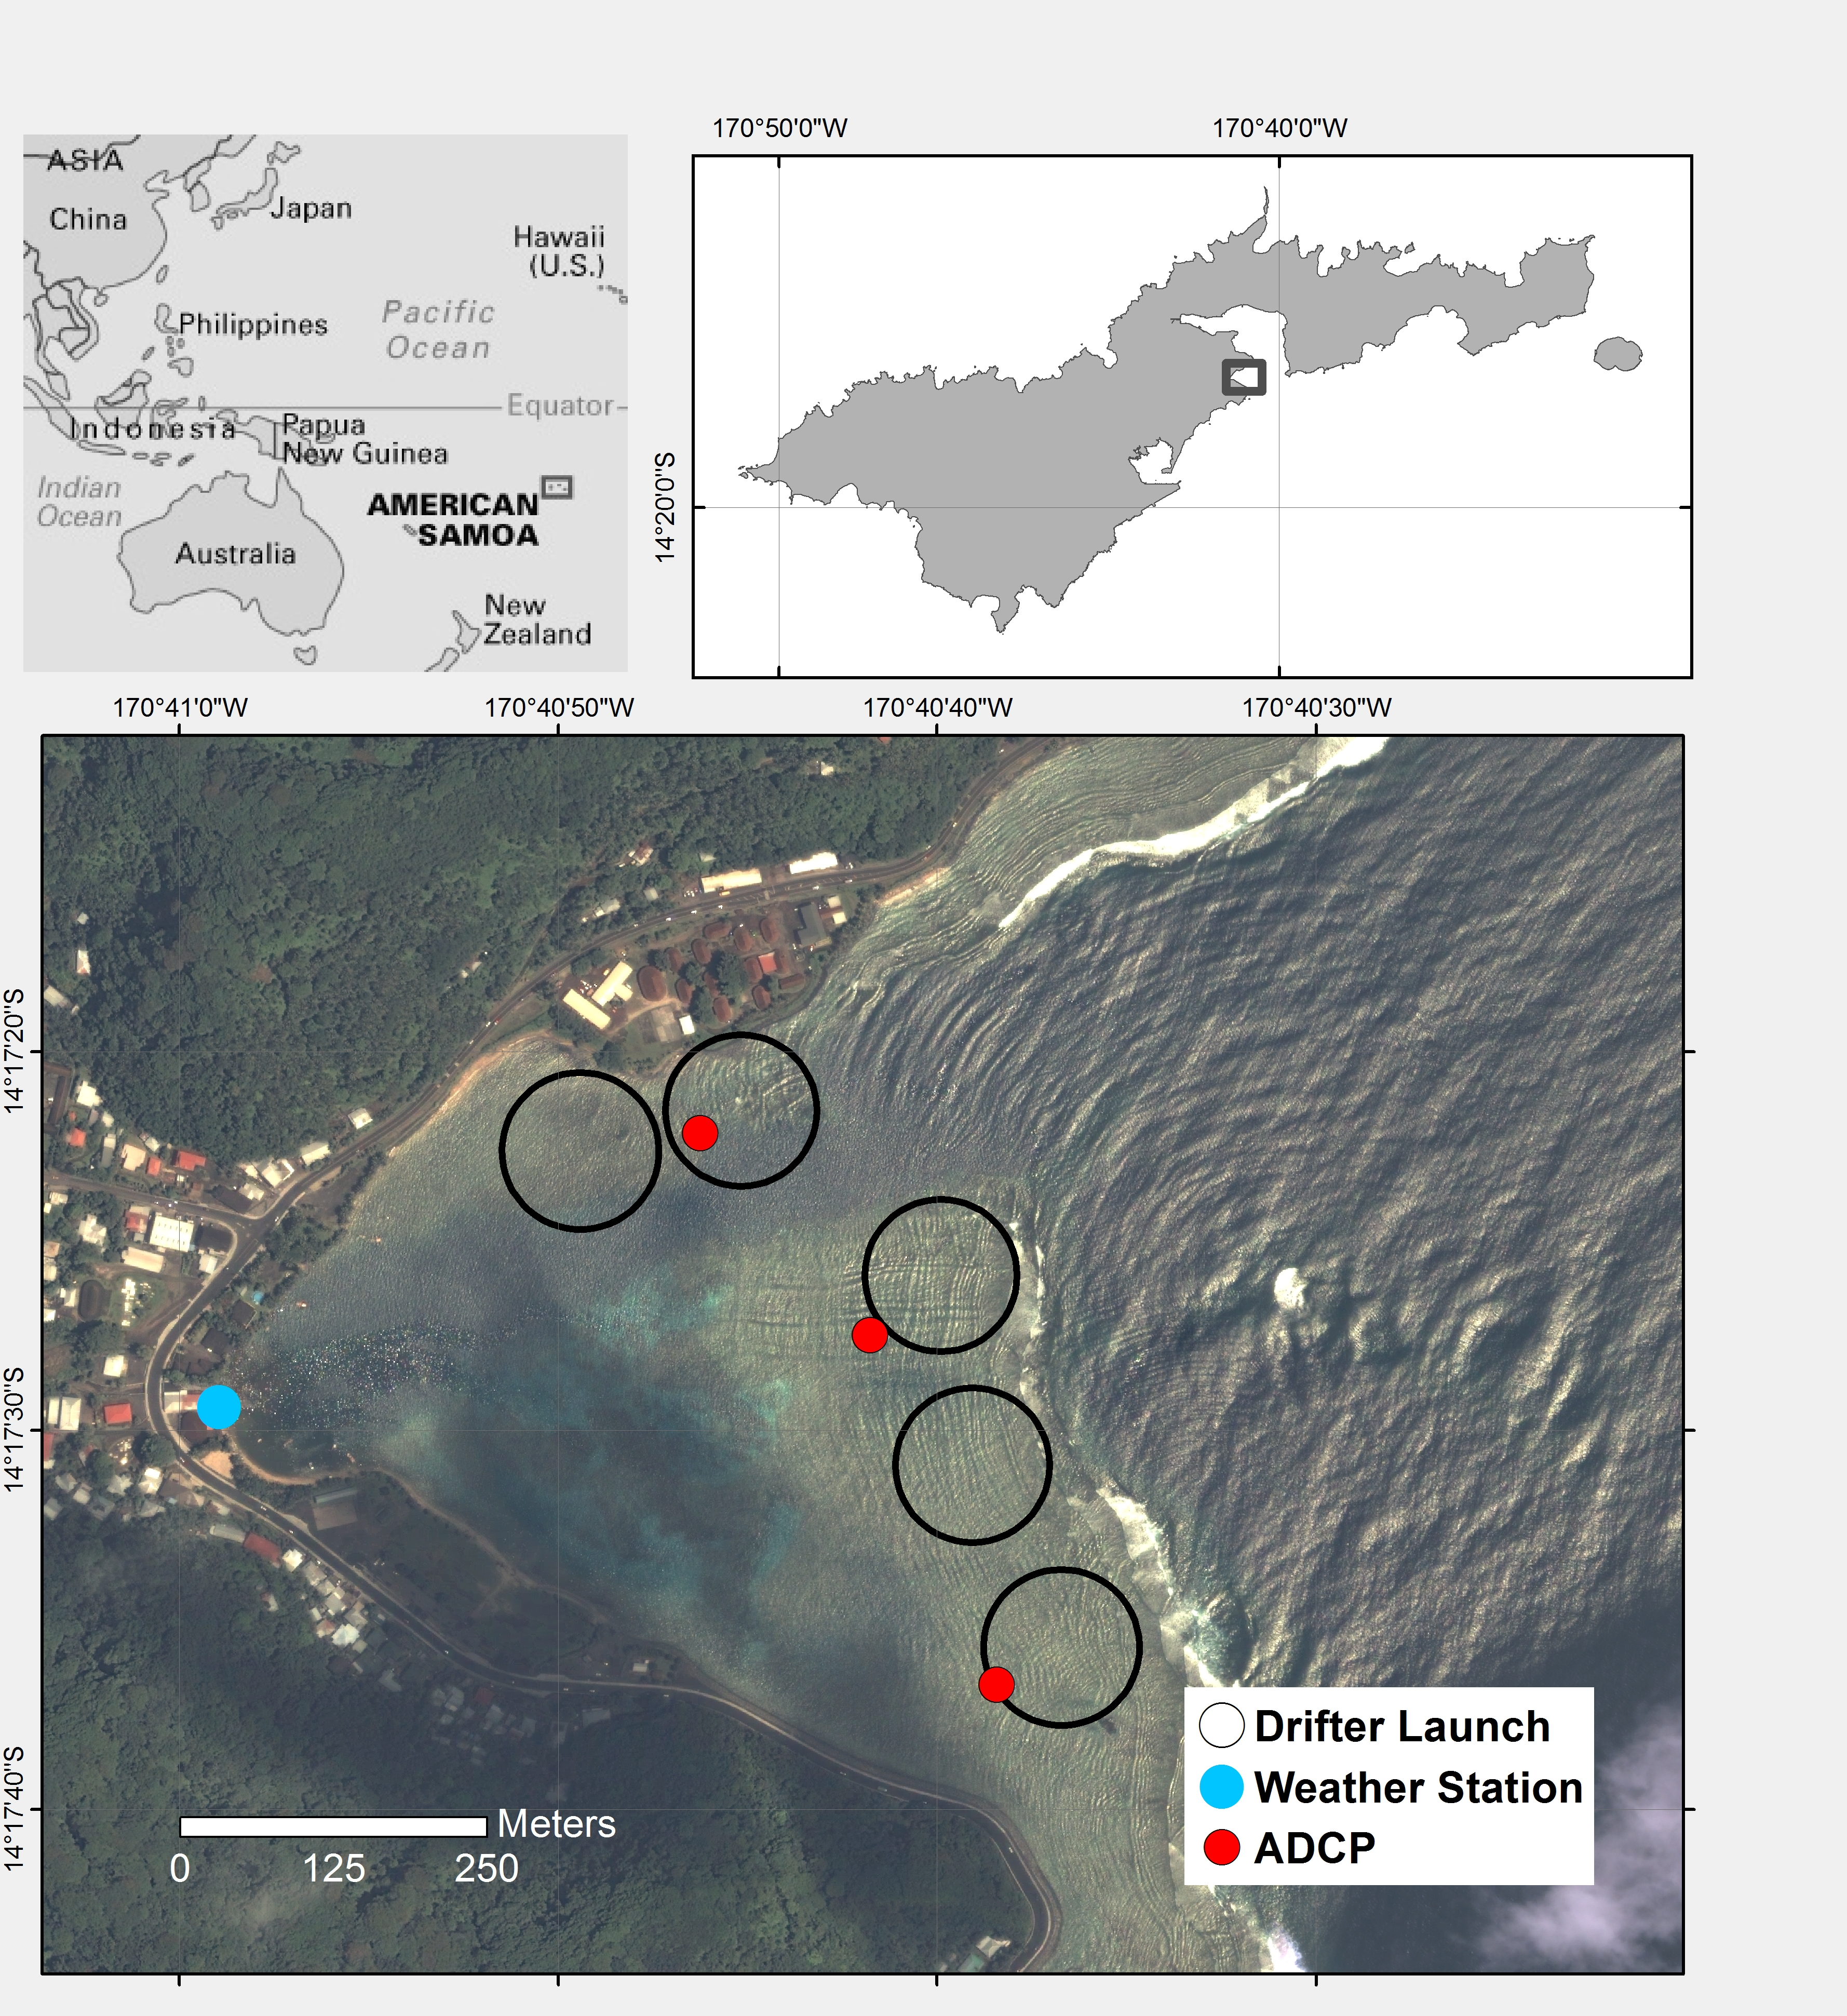

Figure 1. Maps of the study area and locations of instrumentation in Faga'alu Bay. Wind speed and direction were recorded at the weather station (Weather Station), acoustic current profilers were deployed at three locations (ADCP) for one week to measure current speed and direction, and GPS-logging drifters were deployed thirty times (January to March, 2014) from five launch zones (Drifter Launch).

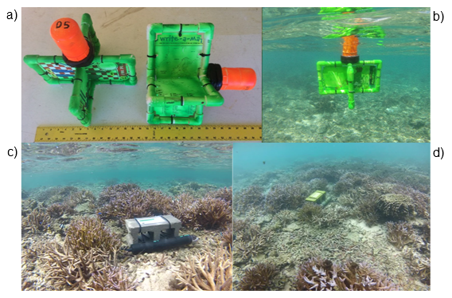

Figure 2. Images of the oceanographic instrumentation used in the study: a) Shallow-water drifters on land with ruler for scale. b) Shallow-water drifter deployed in the field over the southern reef flat. c) The acoustic current profiler at location AS1. d) The acoustic current profiler deployed at location AS2

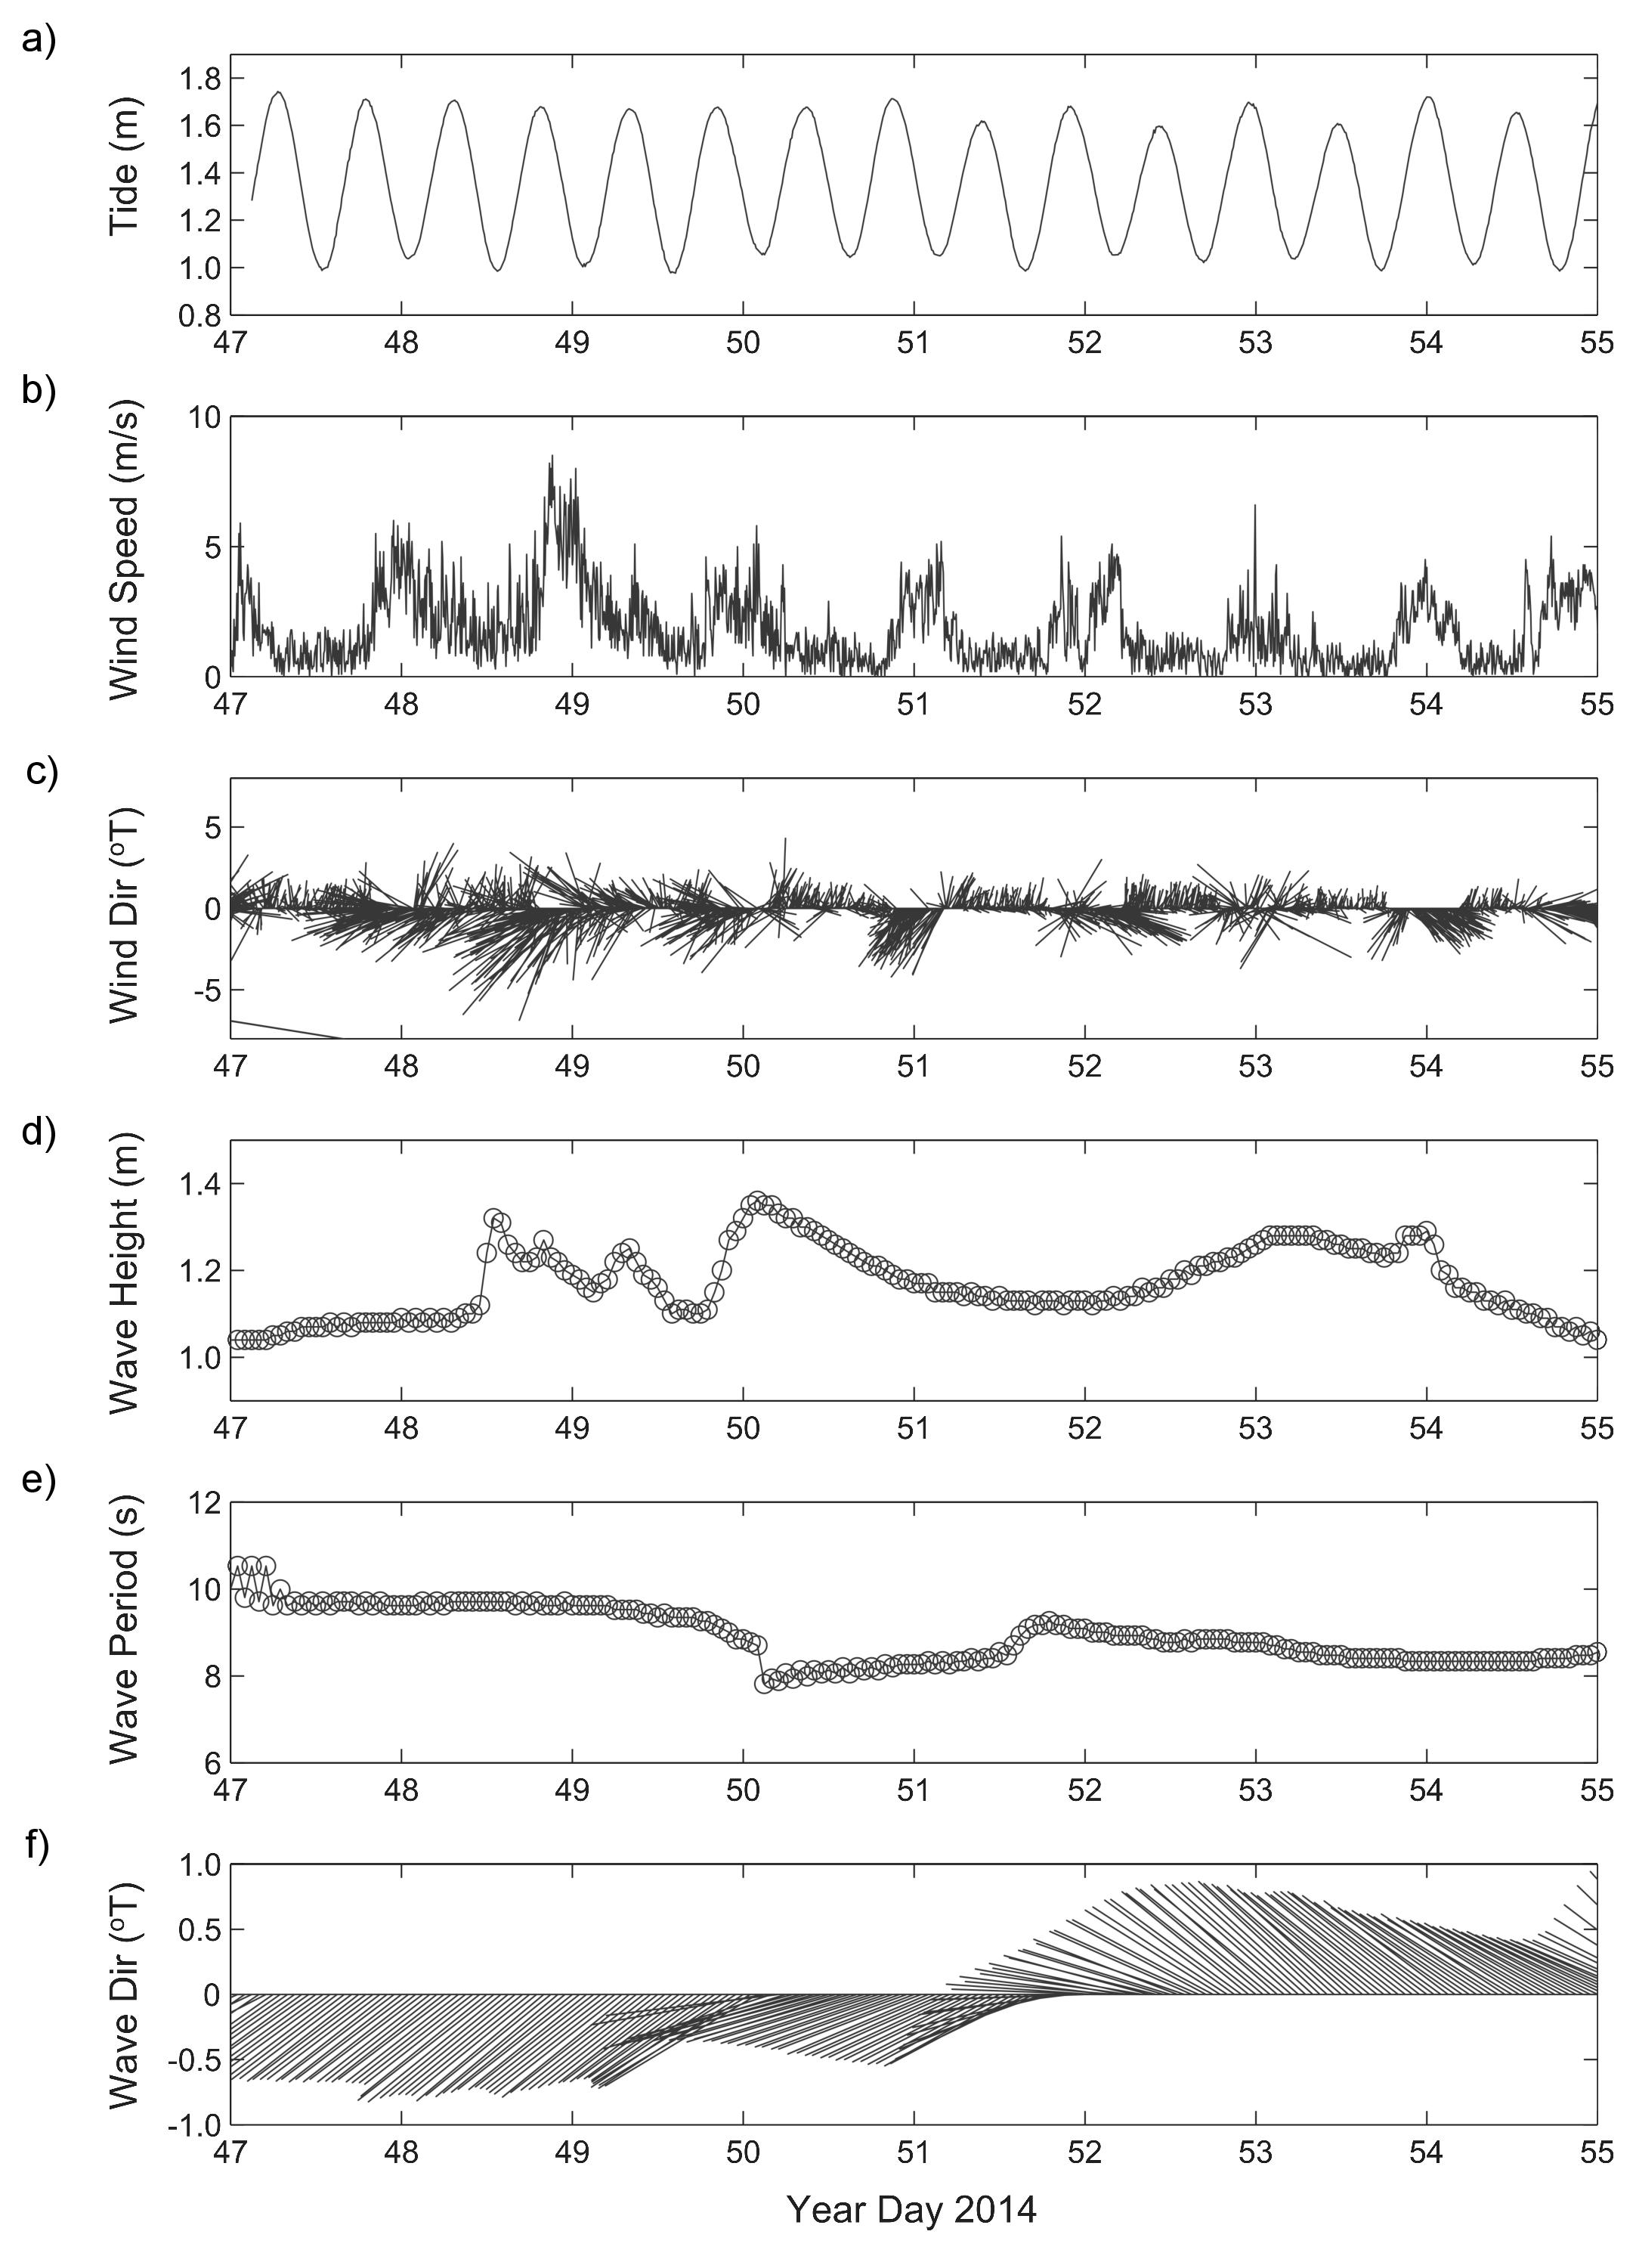

Figure 3. Time series of physical forcing data was used to define end-member periods for analysis. a) Tidal stage. b) Wind speed. c) Wind speed and direction. d) Wave height. e) Wave period. f) Wave height and direction. Vectors denote direction "to". Wind data are from NDBC station NSTP6; wave model data are from NOAA WW3.

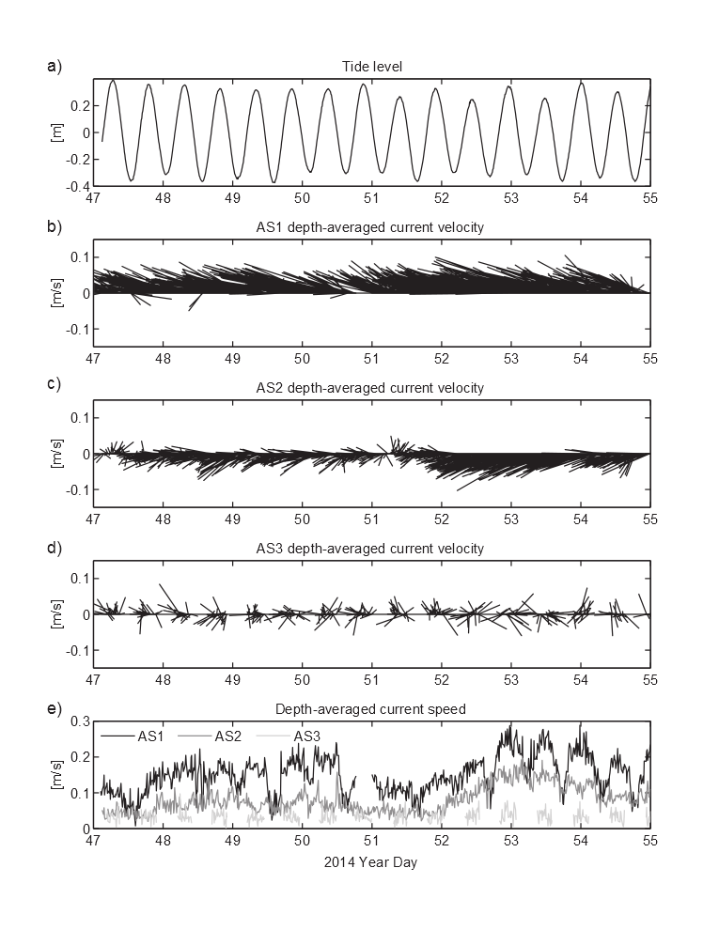

Figure 4. Time series of acoustic current profilers data on the reef flats a) Tide level at location AS1. b) Current speed and direction at AS1. c) Current speed and direction at AS2. d) Current speed and direction at AS3. d) Current speeds at all three locations. Vectors denote direction "to". AS3, water depths at low tide were too shallow to measure currents. Note the variations in current speeds both in space and time due to the different forcing conditions shown in Figure 3.

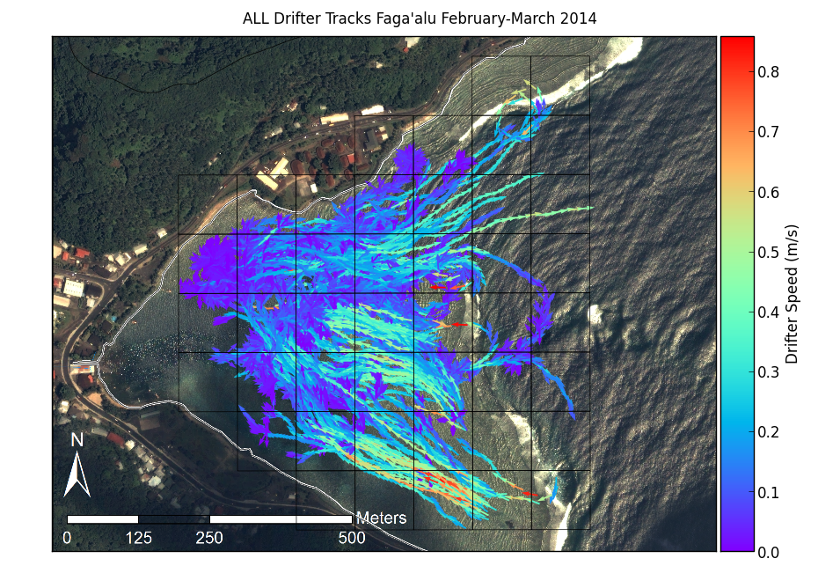

Figure 5. Map of all drifter tracks during the experiment, colored by speed (m/s).

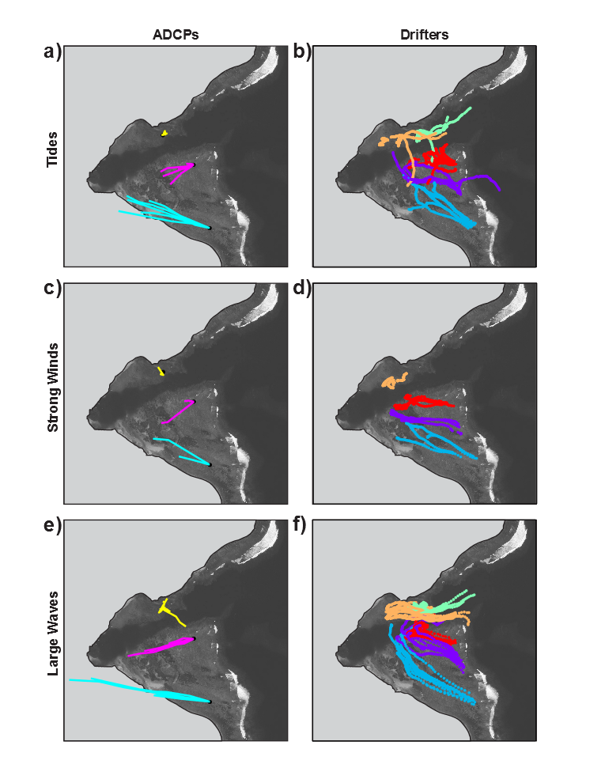

Figure 6. Progressive vectors calculated from acoustic current profiler (ADCP) data, compared to drifter tracks under end-member forcing conditions: a) ADCP data under tidal forcing. b) Drifter data under tidal forcing. c) ADCP data during strong winds. d) Drifter data during strong winds. d) ADCP data during large waves. f) Drifter data during large waves.

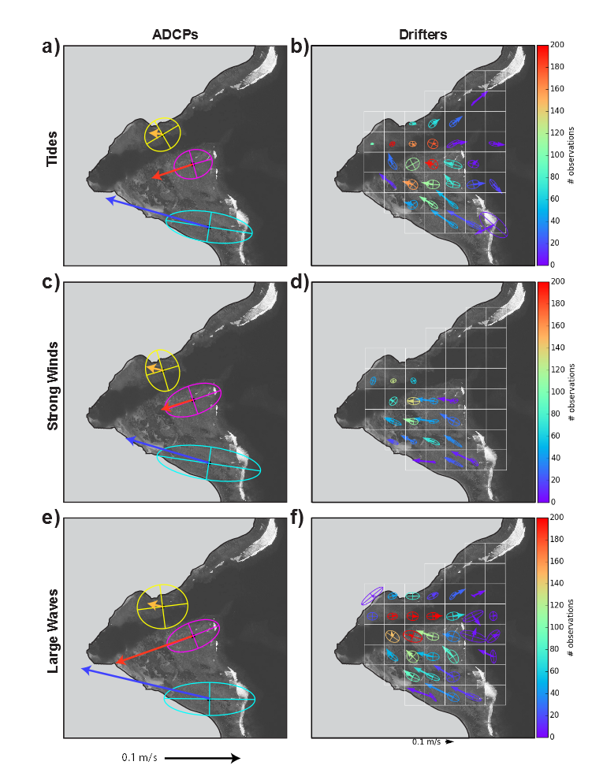

Figure 7. Variance ellipses and mean current vectors for the ADCP data and spatially binned drifter data under different end member forcing conditions. a) ADCP data under tidal forcing. b) Drifter data under tidal forcing. c) ADCP data during strong winds. d) Drifter data during strong winds. d) ADCP data during large waves. f) Drifter data during large waves. Drifter data are colored by number of observations to illustrate the varying data density.

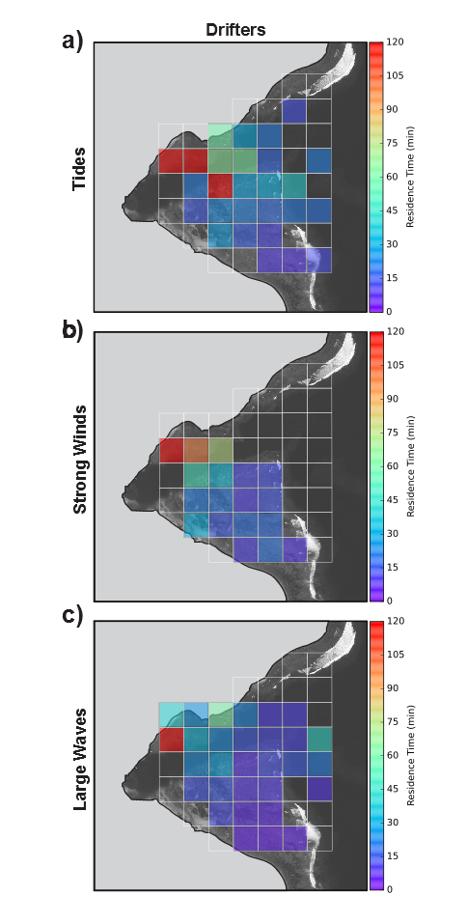

Figure 8. Residence time calculated from mean velocity of drifters under endmember conditions. a) Tidal forcing. b) Strong winds. c) Large waves.

Table 1. Mean flow speed and residence time computed from the ADCPs and corresponding spatially binned drifter data for different forcing conditions.

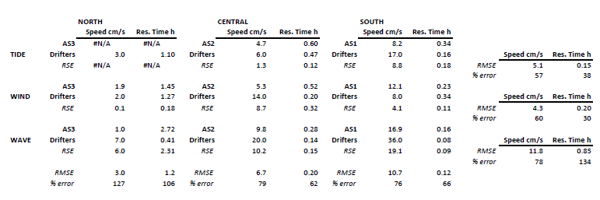

|  |  |  |  |  |  |  |  |  |  |  |
| --- | --- | --- | --- | --- | --- | --- | --- | --- | --- | --- |
| **Table 1.** Drifter deployment dates and conditions. Red numbered Deployments coincide with ADCP deployment | | | | | | | | | | |
| Deployment | Year Day 2014 (local) | Start Time | End Time | Tide Start m | Tide End m | Tide movement m | Wind Speed Avg m/s | Wind Gust Max m/s | Wind Direction Avg deg | Wave Height m |
| 1 | 19 | 1300 | 1500 | 1.5 | 0.3 | -0.17 | 0.6 | 2.0 | 232 | 0.0-0.6 |
| 2 | 20 | 1615 | 1730 | 1.0 | 0.4 | 0.06 | 1.2 | 4.0 | 193 | 0.3-0.6 |
| 3 | 20 | 1750 | 1900 | 1.2 | 0.6 | 0.22 | 1.7 | 5.0 | 258 | 0.3-0.6 |
| 4 | 32 | 900 | 1100 | 3.7 | 0.8 | -0.35 | 2.7 | 6.0 | 96 | 0-0.3 |
| 5 | 32 | 1130 | 1300 | 2.2 | 0.3 | -0.41 | 2.9 | 7.0 | 100 | 0-0.3 |
| 6 | 32 | 1700 | 1900 | 1.5 | 1.0 | 0.52 | 2.2 | 7.0 | 187 | 0-0.3 |
| 7 | 39 | 1415 | 1545 | 3.1 | 1.1 | 0.11 | 2.7 | 9.0 | 140 | 0.6-1.3 |
| 8 | 39 | 1605 | 1800 | 3.3 | 0.8 | -0.24 | 3.1 | 10.0 | 144 | 0.6-1.3 |
| 9 | 47 | 1654 | 1846 | 2.4 | 1.0 | 0.26 | 1.7 | 5.0 | 168 | 0.0-0.6 |
| 10 | 48 | 1245 | 1500 | 1.6 | 0.3 | -0.16 | 5.0 | 14.0 | 79 | 0.6-1.3 |
| 11 | 48 | 1530 | 1700 | 1.1 | 0.5 | 0.14 | 3.0 | 10.0 | 101 | 0.6-1.3 |
| 12 | 48 | 1710 | 1840 | 1.6 | 0.8 | 0.29 | 2.7 | 8.0 | 89 | 0.6-1.3 |
| 13 | 49 | 1245 | 1445 | 2.1 | 0.4 | -0.25 | 2.5 | 7.0 | 97 | 0.6-1.3 |
| 14 | 49 | 1445 | 1700 | 1.3 | 0.4 | 0.02 | 2.4 | 8.0 | 194 | 0.6-1.3 |
| 15 | 50 | 1205 | 1440 | 2.9 | 0.5 | -0.42 | 3.0 | 6.0 | 39 | 0.6-1.3 |
| 16 | 50 | 1445 | 1720 | 1.5 | 0.4 | -0.08 | 3.4 | 8.0 | 54 | 0.6-1.3 |
| 17 | 51 | 840 | 1045 | 2.5 | 1.0 | 0.19 | 2.5 | 7.0 | 290 | 0.0-0.6 |
| 18 | 51 | 1100 | 1200 | 3.2 | 0.9 | -0.05 | 2.2 | 6.0 | 117 | 0.0-0.6 |
| 19 | 51 | 1210 | 1430 | 3.0 | 0.6 | -0.29 | 1.5 | 6.0 | 237 | 0.0-0.6 |
| 20 | 51 | 1500 | 1630 | 1.8 | 0.4 | -0.17 | 3.1 | 7.0 | 290 | 0.0-0.6 |
| 21 | 52 | 920 | 1040 | 2.4 | 0.9 | 0.18 | 1.5 | 6.0 | 253 | 1.0-2.0 |
| 22 | 52 | 1040 | 1145 | 3.0 | 1.0 | 0.09 | 2.0 | 6.0 | 111 | 1.0-2.0 |
| 23 | 52 | 1300 | 1400 | 3.2 | 0.9 | -0.08 | 1.5 | 8.0 | 193 | 1.0-2.0 |
| 24 | 52 | 1500 | 1550 | 2.4 | 0.6 | -0.16 | 1.9 | 6.0 | 152 | 1.0-2.0 |
| 25 | 53 | 1100 | 1215 | 2.7 | 1.0 | 0.14 | 2.8 | 7.0 | 313 | 1.0-2.0 |
| 26 | 53 | 1220 | 1315 | 3.2 | 1.0 | 0.05 | 3.3 | 6.0 | 301 | 1.0-2.0 |
| 27 | 53 | 1600 | 1700 | 2.4 | 0.6 | -0.16 | 2.1 | 5.0 | 310 | 1.0-2.0 |
| 28 | 53 | 1700 | 1845 | 1.9 | 0.4 | -0.22 | 1.0 | 5.0 | 242 | 1.0-2.0 |
| 29 | 54 | 1040 | 1210 | 2.0 | 0.9 | 0.27 | 3.7 | 8.0 | 304 | 0.6-1.3 |
| 30 | 54 | 1210 | 1255 | 2.9 | 1.0 | 0.11 | 2.7 | 6.0 | 260 | 0.6-1.3 |